Q-5-1

1) The following table shows the responses from a sample of 680 people in the General Social Survey to the question, "Do you sometimes drink more than you think you should?"
 | Drink more than should?
Gender | Yes | No | Total
Male | 151 | 177 | 328
Female | 92 | 260 | 352
Total | 243 | 437 | 680
What proportion of males responded that they drink more than they should?
a. 151/243
b. 151/328
c. 243/680
d. 151/680

2) The following table shows the responses from a sample of 680 people in the General Social Survey to the question, "Do you sometimes drink more than you think you should?"
 | Drink more than should?
Gender | Yes | No | Total
Male | 151 | 177 | 328
Female | 92 | 260 | 352
Total | 243 | 437 | 680
Does there appear to be an association between gender and whether a person responds that they drink more than they should?
a. Yes, since a different number of people of each gender are in the sample.
b. Yes, since the percent that responded that they drink more than they should differs from 50%.
c. Yes, since the proportion who responded they drink more than they should differs between males and females.
d. No, there does not appear to be an association between these two variables.

3) A study published in 2007 by Christopher Johnson, professor of music education and music therapy at the University of Kansas, revealed that students in elementary schools who took private music lessons scored around 20 percent higher in math scores on standardized tests, compared to students who did not take private music lessons.
What is the explanatory variable?
a. Music therapy
b. Whether a student took private music lessons
c. Math score on standardized test
d. Grade level

4) A study published in 2007 by Christopher Johnson, professor of music education and music therapy at the University of Kansas, revealed that students in elementary schools who took private music lessons scored around 20 percent higher in math scores on standardized tests, compared to students who did not take private music lessons.
What is the response variable?
a. Music therapy
b. Whether a student took private music lessons
c. Math score on standardized test
d. Grade level

5) A study published in 2007 by Christopher Johnson, professor of music education and music therapy at the University of Kansas, revealed that students in elementary schools who took private music lessons scored around 20 percent higher in math scores on standardized tests, compared to students who did not take private music lessons.
Which of the following could be a potential confounding variable?
a. Household income
b. Socio-economic status
c. Whether the parents hired a math tutor
d. All of the above

6) In a study on sleep habits, it was found that college students who got at least 7 hours of sleep the night before a test performed better on exams than college students who got less than 7 hours of sleep.
In the following diagram, what could be written in place of (1) and (2) to describe a potential confounding variable in this study?
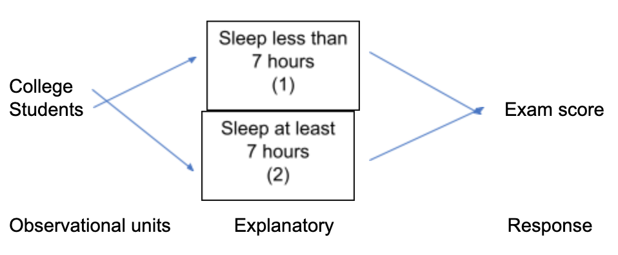
a. Enrolled in more credit hours, Enrolled in less credit hours
b. Enrolled in less credit hours, Enrolled in more credit hours
c. Perform better on exams, Perform worse on exams
d. Perform worse on exams, Perform better on exams

